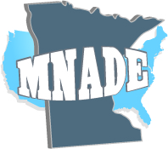
Success Scholarship Application

MNADE’s Student Success Scholarship was created in 2019 to assist students in developmental education with up to $250 to use toward their academic journeys. To nominate a student, you must be a current MNADE member. To update your registration or donate to the scholarship fund, visit: www.mnade.net

Nominations are due by October 15th of each year. Nominators will be notified prior to the end of fall semester and must work with MNADE to contact the recipient. Please email completed applications to erin.manthey@gmail.com

Criteria
The nominee must:
- Be a current student
- Be enrolled in developmental courses or have completed DE course(s) within the last semester
- Demonstrate a need for the award

MNADE Member:
MNADE Member’s Institution: | MNADE Member’s Email
Nominee:
Nominee’s Institution:
Please list all semesters that student was/is enrolled in developmental education courses
Please describe the student you are nominating and why they deserve to win a $250 scholarship from MNADE. This should be completed by the MNADE member. (300 words or less)

